*Zingiber officinale*

**Common Name** – Ginger (Adrak)

**Abstract**

Ginger has multifarious uses. It is cooking ingredient that adds a sharp aromatic flavour, its strong smell is used in making perfumes and it contributes heavily as a remedy for various ailments too. There is a common misconception about ginger being a root as it grows below the ground. In actuality it is the [stem](https://www.lybrate.com/medicine/stem-400-mg-tablet) of the ginger plant. These types of underground stems are called rhizomes. Its scientific name is Zingiber Officinale. The scientific name is believed to have been derived from its Sanskrit name – Singabera (horn shaped). The fleshy part of ginger can be of three colours, yellow, white or red depending upon its variety. It is covered in a light brown skin which might have stripes on it. The taste of ginger is pungent and hot. Ginger has made its way to the FDA’s list of generally safe foods.

## Nutritional Value of Ginger (Adrak)

Ginger has gained a reputation as an extremely nutritional spice and this makes it more suitable for its remedial role. 100g of fresh ginger has 79 calories, 17.86g of carbohydrate, 3.6g of dietary fibre, 3.57g of [protein](https://www.lybrate.com/topic/protein-benefits-sources-and-side-effects), 14mg [sodium](https://www.lybrate.com/topic/sodium-benefits-sources-and-side-effects), 1.15g of [iron](https://www.lybrate.com/topic/iron-benefits-sources-and-side-effects), 7.7mg of [vitamin c](https://www.lybrate.com/topic/vitamin-c-benefits-sources-and-side-effects), 33mg of [potassium](https://www.lybrate.com/topic/potassium-benefits-sources-and-side-effects) and no [sugar](https://www.lybrate.com/topic/sugar). It is power pack of nature’s goodness. Apart from this, ginger also has vitamin B6, [magnesium](https://www.lybrate.com/medicine/magnesium), phosphorus, [zinc](https://www.lybrate.com/topic/zinc-sources-benefits-and-side-effects), folate, riboflavin and [niacin](https://www.lybrate.com/medicine/niacin-nf-tablet).

### Nutritional facts Per 100 grams

## Health Benefits of Ginger (Adrak)

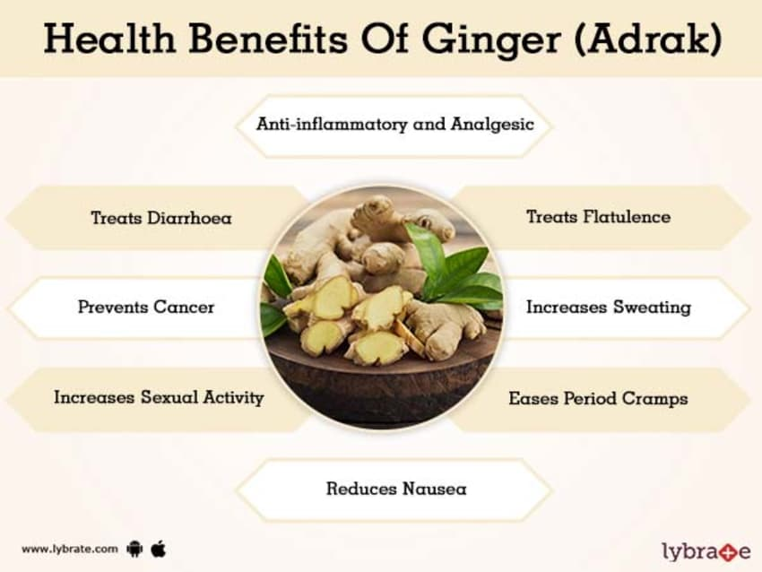

Mentioned below are the best health benefits of Ginger (Adrak)

### Anti-inflammatory and Analgesic

Ginger contains various beneficial compounds that are called gingerols which work miracles in reducing pain and [swelling](https://www.lybrate.com/treatment-for-swelling). These compounds supress chemokines and cytokines which are the compounds that causes inflammation. Hence ginger kills the cause of inflammation in its roots. It not only works to prevent pain and inflammation, but also cures it.

### Treats Diarrhoea

Ginger prevents stomach spasm. These spasms are a major cause for [diarrhoea](https://www.lybrate.com/topic/diarrhoea). This remedy was known to the ancient Chinese for ages. The Chinese would give ginger powder to those suffering from diarrhoea and the scientists today validate this property and function of ginger.

### Treats Flatulence

Gas formation in the body is a natural phenomenon. But when it happens in excess, it becomes a matter of concern. Excess gas formation is known as flatulence and it causes pain and discomfort. Ginger being an amazing carminative agent helps release this excess gas and prevents further accumulation. This way ginger prevents any damage to the delicate organs in the upper torso that may happen due to the excess gas pushing upwards from the stomach.

### Prevents Cancer

Ginger has one of the most important attributes among all other plants- [cancer](https://www.lybrate.com/topic/cancer) preventive. Gingerols, the compounds which makes ginger an effective anti-inflammatory also helps in reducing cancerous activities in the colon. Such activities lead to cancer of the colon and the rectum. Ginger is the gastrointestinal systems best friend and helps it in many ways and this being the most important benefit. Recent studies have also revealed that it prevents the growth of [ovarian cancer](https://www.lybrate.com/topic/ovarian-cancer) cells and reduces tumours without affecting the surrounding healthy cells.

### Increases Sweating

Who likes to sweat? But after reading this you will surely want to sweat whether you like it or not. [Sweating](https://www.lybrate.com/treatment-for-sweating) detoxifies your body. It cleans your pores and carries out your bodily toxins along with it. It also contains an anti-germ compound called dermicidin that has been seen to be effective in reducing bacterial and viral infections. A person who sweats regularly develops a protective layer of this compound on their skin.

### Increases Sexual Activity

Ginger for ages has been used as an aphrodisiac. It works well to arouse sexual desires and enhance such activities. Its aroma helps in making sexual contacts. As ginger increases blood circulation, sexual urges are increased and this enhances sexual activities.

### Eases Period Cramps

Ginger reduces the level of prostaglandin hormone that function as chemical messengers. This hormone is responsible for bringing about cramps, pains and fevers in the body. [Menstrual cramps](https://www.lybrate.com/topic/menstrual-cramps) too are caused by this prostaglandin hormone being present in the blood. Hence chewing on ginger helps reduce period cramps.

### Reduces Nausea

[Nausea](https://www.lybrate.com/treatment-for-nausea) is a problem commonly associated with [pregnancy](https://www.lybrate.com/topic/pregnancy), travelling especially in winding roads for those who suffer from [motion sickness](https://www.lybrate.com/topic/motion-sickness) and patients undergoing [chemotherapy](https://www.lybrate.com/topic/chemotherapy). Ginger soothes body functions specifically in the gut. It also helps increase the speed of absorption of the food. This makes it effective against nausea without having any side effects.

## Uses of Ginger (Adrak)

Ginger is a spice that all cuisines swear by. Its long list of health benefits is a big reason why this hot pungent herb has been used in cooking for ages and across borders. Ginger has also been seen to reduce [dandruff](https://www.lybrate.com/topic/dandruff) which again is an important use of it.

## Side-Effects & Allergies of Ginger (Adrak)

Ginger is generally a safe food but taking it in excess could cause [acid reflux](https://www.lybrate.com/topic/acid-reflux), irritate the mouth or even start diarrhoea. Pregnant women, those with [gallstones](https://www.lybrate.com/topic/gallstones) or problems with blood clotting should avoid taking ginger in excess.

## Cultivation of Ginger (Adrak)

Ginger has been first mentioned by Confucius in his writings in the 5th century BC. It is believed that this beneficial [stem](https://www.lybrate.com/medicine/stem-400-mg-tablet) is a native of south-eastern Asia. India and China have used ginger in food and medicine since ancient times. It was introduced to the west by traders and through conquests and colonization of various parts of the world which exchanged cultures and exposed them to new things. Ginger needs 8 to 10 months to mature for being harvested. It grows best in a well-drained soil and in a warm and humid climate.